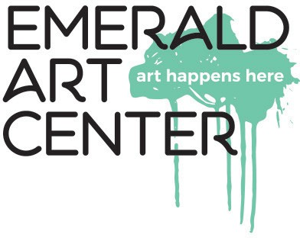
January
Member Art Intake/ Pickup Schedule for 2026
Current Members may submit one or two (space permitting) pieces of artwork to be hung in the gallery as indicated.
Saturday, January 3rd - Pickup & Intake of Membership Artwork
Member Show runs Jan. 6th-30th; 2nd Friday - Jan. 9th; Challenge Theme: Shadows

February
Saturday, January 31st - Pickup & Intake of Membership Artwork
Member Show runs Feb. 3rd-27th; 2nd Friday- Feb. 13th; Challenge Theme: Storm

March
Saturday, February 28th- Pickup & Intake of Membership Artwork
Member Show runs March 3rd-27th; 2nd Friday - March 13th; Challenge Theme: Art with Story*

April
Saturday, March 28th - Pickup & Intake of Membership Artwork
Member Show runs March 31st- April 24th; 2nd Friday- April 10th; Challenge Theme: Poetry

May
Saturday, April 25th - PICKUP ONLY of Membership Artwork NJS Hand Delivered Art Intake April 24th & 25th National Juried Show runs April 28th - May 29th
NJS Awards Reception Sat. May 2nd; 2nd Friday- May 8th

June
Saturday, May 30th - Pickup NJS & Intake of Membership Artwork Member Show runs June 2nd-26th; 2nd Friday- June 12th; Challenge Theme: Busy

July
Saturday, June 27th - Pickup & Intake of Membership Artwork
Member Show runs June 30th- July 31st; 2nd Friday- July 10th; Challenge Theme: Mobile

August
Saturday, August 1st - Pickup & Intake of Membership Artwork
Member Show runs August 4th- 28th; 2nd Friday- August 14th; Challenge Theme: Reflections

September
Saturday August 29th- Pickup & Intake of Membership Artwork
Member Show runs September 1st- 25th; 2nd Friday - Sept. 11th; Challenge Theme: City Scapes

October
Saturday, Sept. 26th PICKUP ONLY of Membership Artwork & Intake for 33rd Annual Springfield Mayor’s Art Show ($25 entry fee) MAS runs Sept. 29th- Oct. 30th
MAS Awards Reception Fri. Oct. 2nd; 2nd Friday- Oct. 9th

November
Saturday, October 31st - Pickup MAS & Intake of Membership Artwork
Member Show runs Nov. 3rd - 25th; 2nd Friday - Nov. 13th; Challenge Theme: Art Deco

December
Saturday, November 28th - Pickup & Intake of Membership Artwork
Member Show runs Dec. 1st - 31st, 2026; 2nd Friday - Dec. 11th; Challenge Theme: Literary Classics

Saturday, January 2nd, 2027 - Pickup & Intake of Membership Artwork
* Art with Story= One piece of art ONLY with bio, story, explanation or description (max.=100 words)

